PHMAP23 Sponsorship

General information of PHMAP23
- Date: September 11 (Mon.) to 14 (Thu.), 2023
  - Exhibition: September 12 (Tue.) to 14 (Thu.)
- Conference website: https://phmap.jp/
- Venue: Hitotsubashi Hall, Tokyo, Japan:
https://www.hit-u.ac.jp/hall/

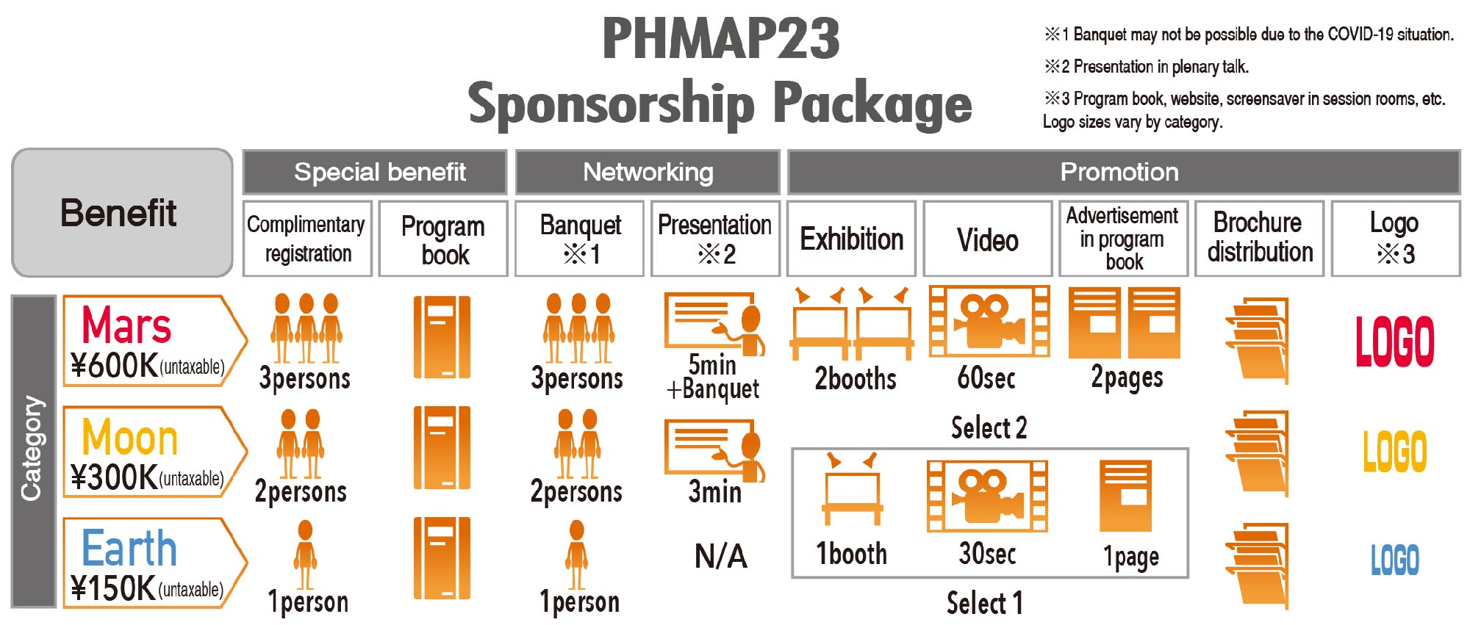
Package information

Deadline
May 31 (Wed.), 2023

Contact
PHMAP23 Secretariat: secretariat[at]phmap.jp

PHMAP23
Sponsorship Application Form

Contact information
Company:

Corresponding person:

Address:

Tel:

E-mail:

Package
Category: □ Mars □ Moon □ Earth

Select two for Moon, one for Earth
□ Exhibition □ Video □ Advertisement in program book

Any comments or requests

